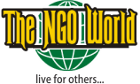

WORLD NGO DAY 2018-Pakistan
EXHIBITOR REGISTRATION FORM

Complete Name of Organization
Address
Phone & Fax
E-Mail
Website
Organization’s Description
(max: 150 words)
Organization Representative Name
Designation
Phone/cell

Return the filled form on exhibition@thengoworld.com

NOTE: Organizers have the right to accept or reject the request. .

Focal person
Mr. Sajjad Nayye,
Event Coordinator
Cell: +92-300-5167078
Email: sajjad.nayyer@thengoworld.org

